Quick guide for Marlin and Octoprint

This guide shows how to download the latest printer firmware for your printer and how to install Octoprint Raspberry on your own.

Install Marlin

You can manually edit and flash Marlin on your printer for your own purposes. It’s recommended just to flash our preconfigured version, so you don’t have to face any issues.

1. Download GitHub Desktop and create an account

2. Download Visual Studio Code and install following extensions: “Platform IO IDE” and “C/C++”

3. Go to GitHub page: https://github.com/iFactory3D/Marlin

4. Fork and Clone the project into GitHub Desktop

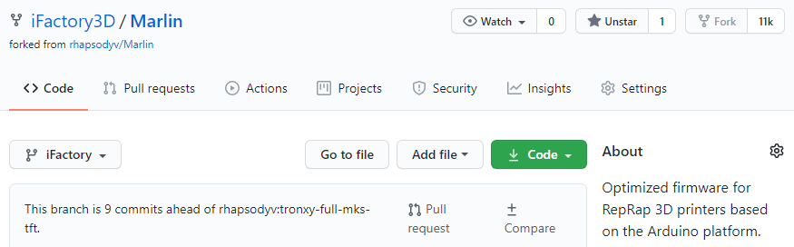

5. In GitHub Desktop, click on the button “Open in Visual Studio Code”

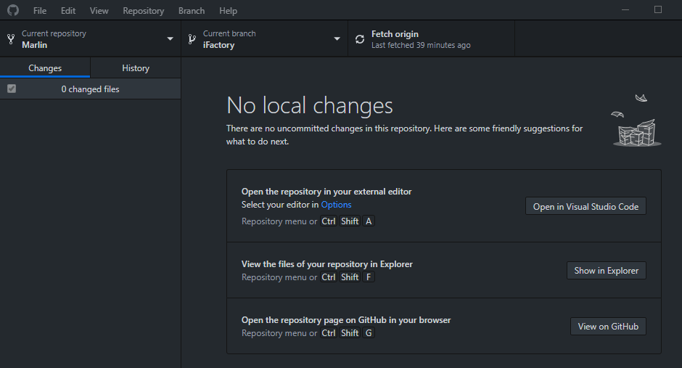

6. When project has been opened, compile and built

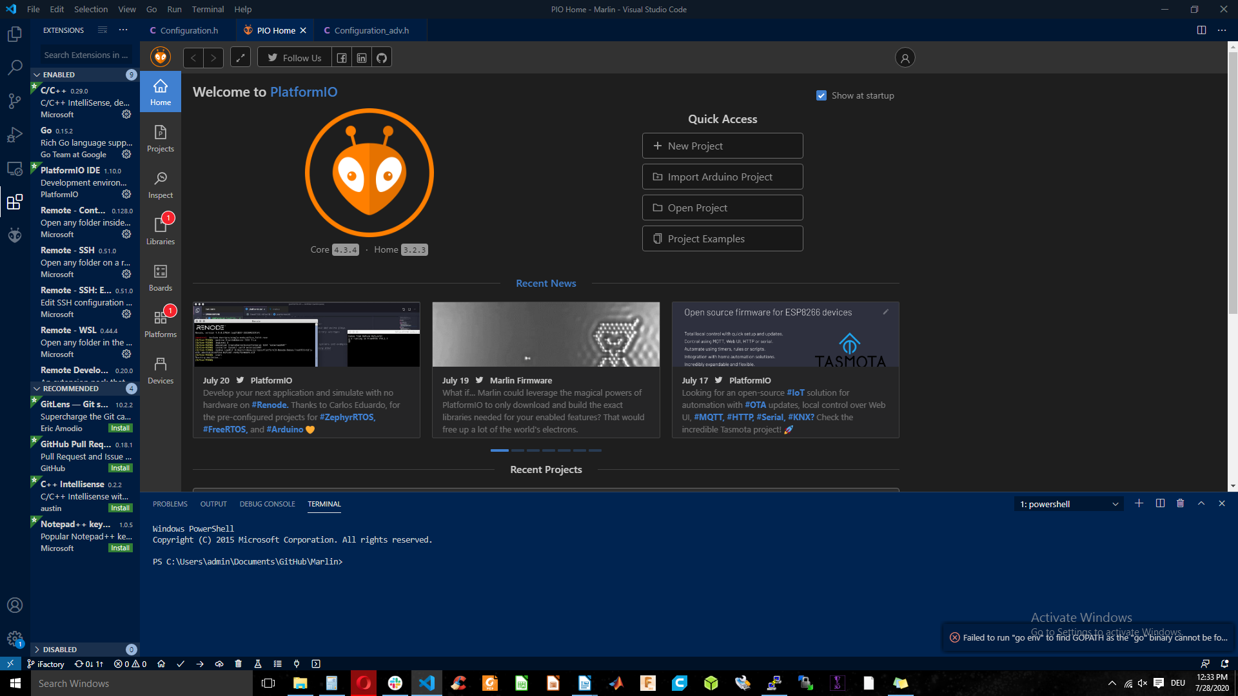

7. A file named “update.cbd” has been created and it is usually stored in this directory:

Documents/GitHub/iFactory/.pio/build/chitu_v5_gpio_init

8. Copy the file to a SD card and insert it in the printer

9. Turn printer on and wait till beeping noises sound 5 times. You are finished!

Install Octoprint

1. Download the image file from our website: xxxxxx

2. Download and install Etcher or similar program to flash .img files on a SD card

3. Flash our image file on your sd card

4. Turn off Raspberry

4. Put sd card in Raspberry and turn on

5. When successfully connected to the printer via USB, you should see the Octoscreen menu after a while. If not, restart Raspberry and printer.

